

Objective:
- Manual Carrier Set Up

Introduction:
Dynamics TMS Carrier Page lists carriers, configuration for carrier fee entry into portal, carrier and scheduler contacts.

Carrier
This document will help guide users to adding a new carrier into the TMS system. Does not apply when using carrier integration from ERP systems.

Adding a New Carrier to System

In the desktop client, click on the NGL icon in the upper left and select NEW and then NEW CARRIER. Or, if you’re using the NAV integration, the carrier will be sent directly to TMS following the Synchronization.
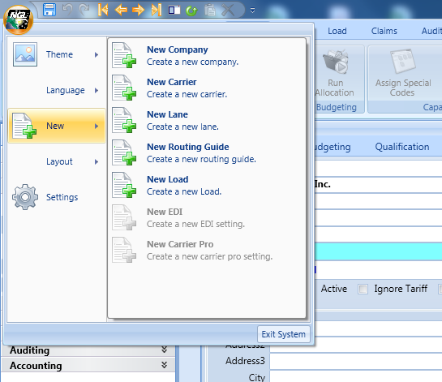
Insert the Carrier Vendor Number. Recommend using the same as your ERP vendor number.
Insert Carrier Name.
Insert Legal Entity.
Insert Carrier SCAC Number.
Insert contact name, phone, and email address. Check the default contact box if tenders are to default to this contact. Only one default can be selected.
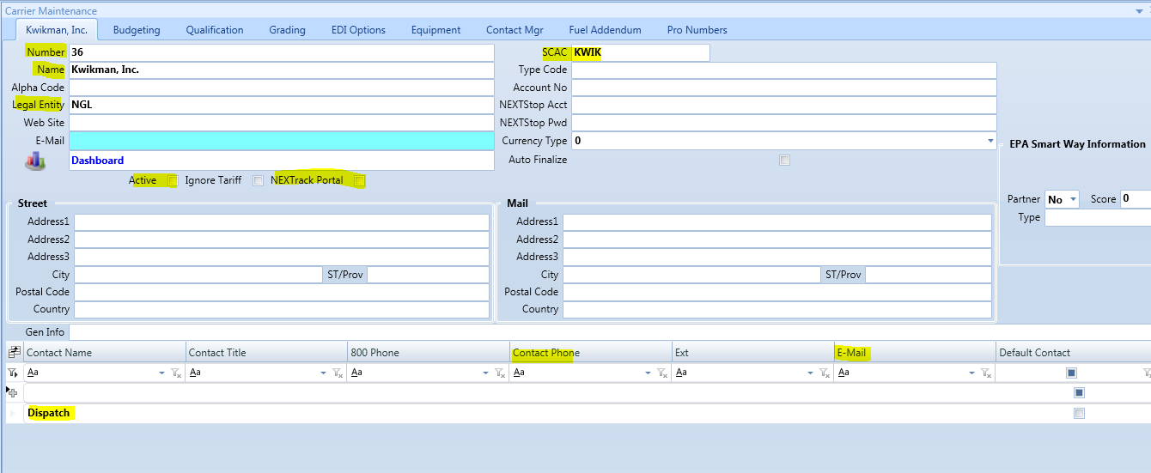

Enter in carrier’s insurance expiration date.
Insert carrier’s cargo liability insurance value per shipment (typically $100,000)
Insert exposure for all open shipments by carrier ($1,000,000 estimated)
Current exposure (auto populated) is running total of open loads with this carrier based on product value.
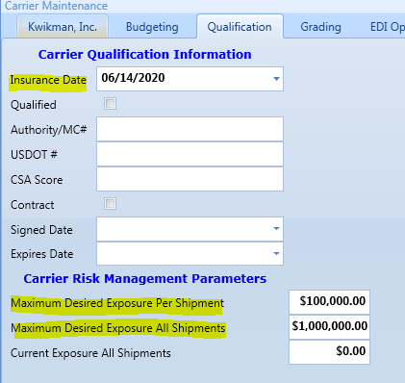
Go to Carrier page in D365 Portal and select Add Carrier.
Use the selection drop down list to find your carrier.
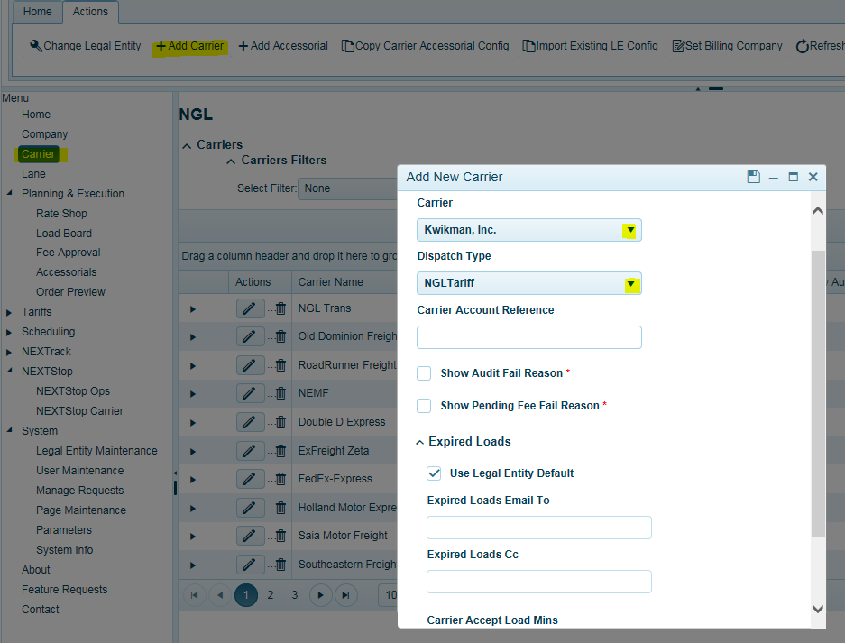
If using the tariff system, select NGL Tariff.

Show Audit Fail Reason = If carrier is set up to use Web Settlement, it will display invoice failed on audit.
Show Pending Fee Fail = If carrier is set up to use Web Settlement, it will display pending approval on audit.
Expired loads is used for web tendering and the time settings used as to when a load tender should expire. There are two settings. 1) Legal Entity (Global default) 2) By carrier.
Enter in TMS distribution email for Expired load notifications. TMSoperations@company.com
When Use Legal Entity Default box is checked, the system will use the default settings for carrier Expired Loads and Carrier Accept Load Mins.
Carrier Accept Load Mins = The amount of time in minutes carriers have to accept a load tender. This can be set at the Legal Entity level or carrier specific level. If Legal Entity is checked, the system will use the Legal Entity default setting. Note, this does not impact API carriers.
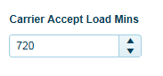
To apply carrier specific settings, uncheck the box for Use Legal Entity Default and insert your email address and accept load time in minutes. This setting will be for this carrier only.
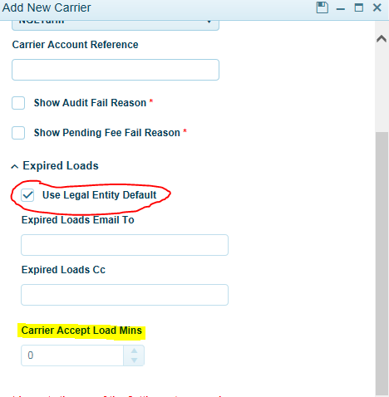
If new carrier supports multi location pick up LTL consolidation, check Allow LTL Multi-Pick Consolidations. The system will calculate freight costs based on the aggregated weight from each location, shipping to the same delivery location. Additional set up in the Parameters is required. See support for assistance.
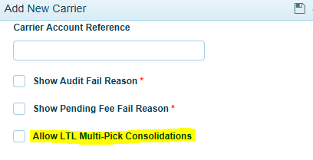

Carrier Fee Entry Setup
Once you have completed the carrier set up, you will now want to complete the carrier fees set up to enable carriers to enter their fee(s) and invoices in the portal or EDI 210’s depending on your TMS configuration. If you’re entering freight invoices manually and using the Quick Edit entry, then you do not have to complete this step.
In the Carrier Page click on the Actions Tab.
Click on Carrier Name so it turns blue.
Click Add Accessorials.
This is where you will set up all fees unique to this carrier and fees you expect them to enter into the system when entering invoices or for receiving fees via EDI 210’s. Each configuration can contain a variety of fee(s). User should apply all fees possible for each carrier. Most common will be fees such as:
• Unloading • Detention (Origin) • Detention (Destination)
• Tarp fee • Re-delivery • Stop charges
• Misc (this is a for any fee that may not be configured but allows entry by carrier)
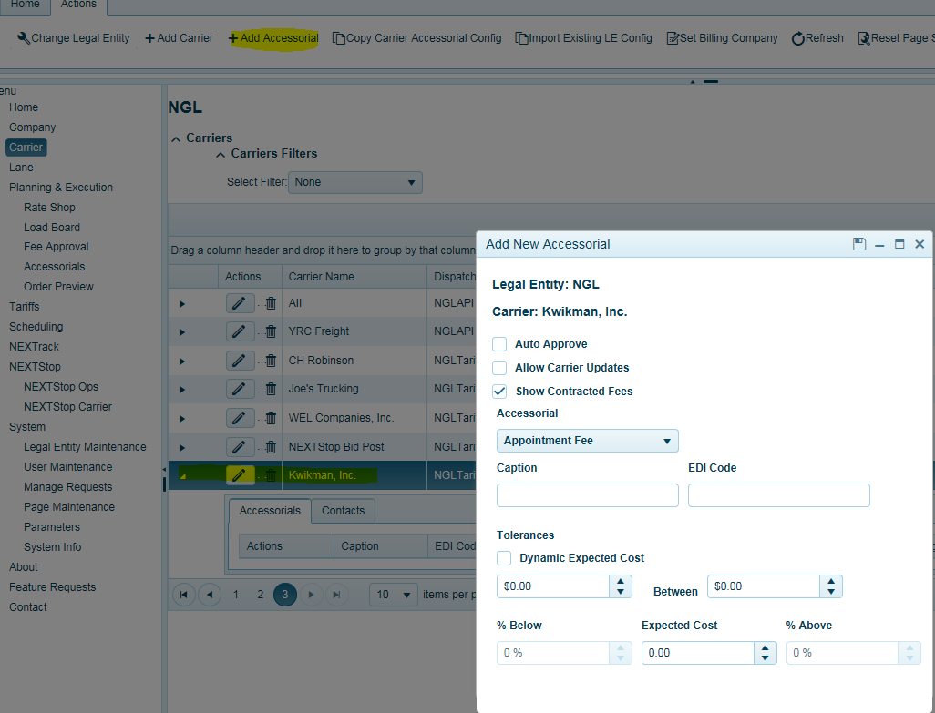
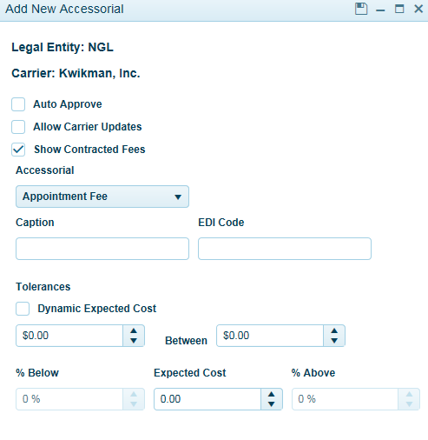
For each fee you apply, you must select the workflow configuration you desire by checking the boxes and click save when done.
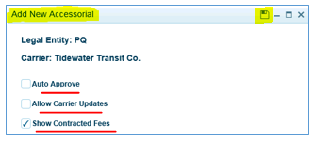

Auto Approve = If fee is within tolerance, it will bypass manual/tms user approval if checked on. If not checked, users will have to approve this fee each time to pass audit.
Allow Carrier Updates = Allows carriers to edit a pre-determined fee when entering an invoice if checked on. Recommended to be checked.
Show Contracted Fees = Precalculated fees as part of the carrier’s tariff and will display in the Carrier invoice entry screen if checked on. If not checked, carriers will not see fee and will not be able to change/update fee. Recommended to be checked.
Select your fee from the drop-down list. These fees are loaded from the TMS Accessorials table in the Load Planning page. It is important to configure and make available all fees to carriers you expect them to enter or when EDI is being used. If a fee does not appear here, the web settlement carrier will not see the fee and it must be set up in order for carrier to insert fee. Web Settlement Carriers should contact TMS users to set up fee if missing. When receiving 210 EDI invoices, any missing fee will go to the approval screen with a notification. User should configure this fee for this carrier for the next time in Carrier page.
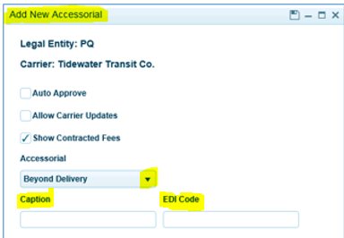
Once your fee is selected from the drop-down list, the Caption field and EDI Code (if set up) will auto populate. Users should not modify EDI Code field unless they feel and have confirmed it is incorrect per carrier EDI Set up.

Fee Tolerance Set Up
The next step would be to apply your tolerance ranges. There are three different settings. First is a flat dollar low and high range. Second, you can apply a percentage low and high range against a known value. Third, is Dynamic Expected Cost. If no known value is entered, the percentage low and high ranges will compare against the fee entry.
- Each Fee for each Carrier has individual settings assigned to each Legal Entity.
  - Flat Rate Low Value: minimum dollar value allowed; typically, zero.
  - Flat Rate High Value: maximum dollar value allowed.
  - Expected Cost: The Expected Cost is only used with the percentage tolerance calculations.
  - Lowest Percentage Factor: based on a pre-determined Expected Cost. The lowest percentage below the Expected Cost that is allowed, typically this is 100%, which will evaluate to a minimum cost of zero dollars.
  - Highest Percentage Factor: base on the Expected Cost, the highest percentage above the Expected Cost that is allowed.
- Calculation Rules:
  - If the Expected Cost is zero, the system will use the Flat Rate values to determine if the Cost falls inside the Flat Rate Tolerances.
  - If the Expected Cost is non-zero, the system will use the Percentage Factors to determine if the Cost falls inside the Percentage Tolerances.
- Flat Rate Formula:
  - If Cost falls below the Flat Rate Low Value the fee cannot be auto-approved.
  - If the Cost exceeds the Flat Rate High Value the fee cannot be auto-approved.

- Low Percentage Factor Formula: If the Cost falls below the Calculated Low Value based on the Low Percentage Factor the fee cannot be auto approved.
  - If Low Percentage Factor is zero, the Calculated Low Value is equal to the Expected Cost; the fee cannot be auto approved if it falls below the Expected Cost.
  - If Low Percentage Factor is greater than zero, we apply the Low Percentage Factor to the Expected Cost: where the Calculated Low Value equals the difference between the Expected Cost and the product of the Expected Cost and the Low Percentage Factor.
  - Example: In this example the Lowest Cost Allowed is $105.00
    - Expected Cost = 150, Low Percentage Factor = 30%.
    - Calculated Low Value = 150 - (150 * 0.30)
    - or $105.00 = $150 - $45.00
- High Percentage Factor Formula: If the Cost exceeds the Calculated High Value based on the High Percentage Factor the fee cannot be auto approved.
  - If the High Percentage Factor equals zero the Calculated High Value is equal to the Expected Cost, the fee cannot be auto approved if it exceeds the Expected Cost.
  - If the High Percentage Factor is greater than zero, we apply the High Percentage Factor to the Expected Cost: where the Calculated High Value equals the sum of the Expected Cost and the product of the Expected Cost and the High Percentage Factor.
  - Example: In this example the Highest Cost Allowed is $195
    - Expected Cost = 150, High Percentage Factor = 30%.
    - Calculated High Value = 150 + (150 * 0.30)
    - or $195.00 = $150 + $45.00
Using Flat Rate example:
Enter in dollar low and high range. Low = $0 High = $195
The fee entered by the carrier must fall between this range.
Percentage values and average value all must be zero and not being applied.
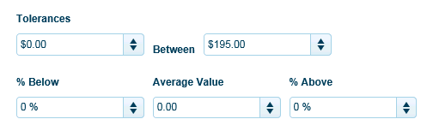

Using Percentage Rate Example:
Dollar value ranges are equal to zero and not being applied.
Percentage values are set to 100% below Expected Cost value ($150) and 30% above (.30 x $150 - $195) Expected Cost Value $150.
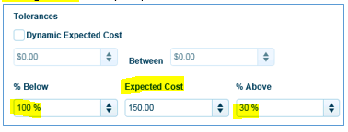
Dynamic Expected Cost
This is used when you want to allow for variability in the fee entry by the carrier. When checked on, you enter in the % Below value (100% to equal zero) and % Above value ranges.
For example: Let’s say you configured fuel to use Dynamic Expected Cost. If your settings were 100% below value and 10% high value and the actual fuel cost for a given load was $225.00. This configuration will allow for $0 on the below value and will allow up to $247.50 (10%) on the high value.
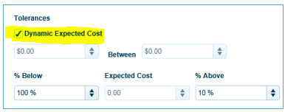
Click on black arrow next to carrier to see all fees set up for this carrier. You can also Edit a fee to make changes or Delete.
